https://www.youtube.com/watch?v=nlz9j-r0U9U&list=PLKnIA16_RmvaTbihpo4MtzVm4XOQa0ER0&index=3
00:00 - Intro
00:57 - What is LangChain?
01:58 - Why do we need LangChain?
04:42 - High Level Discussion of App
26:35 - Benefits of LangChain
30:33 - What can you build with LangChain?
35:50 - Alternatives to LangChain
1. Introduction to LangChain
LangChain is introduced as a foundational framework for building applications powered by Large Language Models (LLMs).
This video is designed to build the mental model required for all future GenAI development.
The focus is not code, but:
- Why LangChain exists
- What problems it solves
- How real systems are designed
- How industry uses it

2. What is LangChain?
Definition
LangChain is an open-source framework for developing applications powered by Large Language Models (LLMs).
In simple terms:
If you want to build any LLM-based application (chatbot, PDF Q&A system, AI agent, etc.), LangChain helps you connect, manage, and orchestrate all components required to make it work end-to-end.
LangChain is not an LLM.
It is a framework around LLMs.

3. Why Do We Need LangChain?
Before understanding LangChain, it’s important to understand the problem without it.
3.1 Real-world Motivation (PDF Chat Example)
A practical problem:
- Users read PDFs (books, research papers, documents)
- They want to:
  - Ask questions
  - Get simplified explanations
  - Generate notes
  - Practice questions
Example questions:
- “Explain page 5 like I’m 5 years old”
- “Generate true/false questions from this chapter”
- “Summarize Decision Trees from this book”
This requires much more than just an LLM.
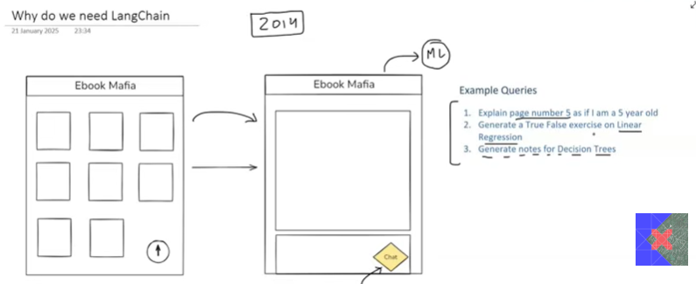

4. High-Level System Design of a PDF Chat Application
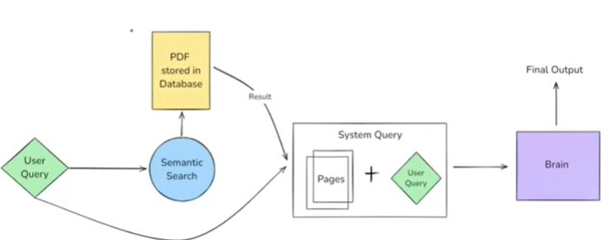
A real GenAI application involves multiple components, not just ChatGPT.
4.1 Core Flow
- User uploads a PDF
- PDF is stored (cloud or storage system)
- User asks a question
- System finds relevant parts of the document
- LLM generates an answer only from relevant context
- Final answer is shown to the user
This is the industry-standard architecture for document-based GenAI apps.

5. Keyword Search vs Semantic Search
5.1 Problem with Keyword Search
Keyword search:
- Matches exact words
- Returns many irrelevant results
- Fails to understand meaning
Example:
- Query: “aspects of linear regression”
- Keyword search may match:
  - “aspects”
  - “linear”
  - “regression” separately
This leads to noisy and inefficient results.

5.2 Semantic Search (Core Concept)
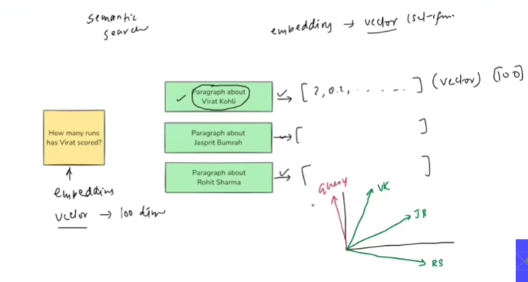
Semantic search focuses on meaning, not exact words.
Process:
- Convert text into embeddings (vectors)
- Convert user query into an embedding
- Compare similarity between vectors
- Retrieve the most meaningful content
Basically query – embedding 1
Responses – embedding 2
Response with more similarity is chosen as the answer
This ensures:
- Fewer results
- More relevant context
- Better answers from LLMs

6. Embeddings Explained (Foundation Concept)
6.1 What are Embeddings?
Embeddings are numerical vector representations of text that capture semantic meaning.
- Text → Vector (numbers)
- Similar meaning → closer vectors
- Different meaning → distant vectors
6.2 Why Embeddings Matter in GenAI
Embeddings enable:
- Semantic search
- Recommendation systems
- Context retrieval
- Long document understanding
This is one of the most important concepts in Generative AI.

7. Low-Level Architecture of the System
7.1 Components Involved
A real GenAI pipeline includes:
- Document Loader – loads PDFs
- Text Splitter – breaks documents into chunks
- Embedding Model – converts text into vectors
- Vector Database – stores embeddings
- Retriever – finds relevant chunks
- LLM (Brain) – understands query and generates answer
Each component is independent but connected.
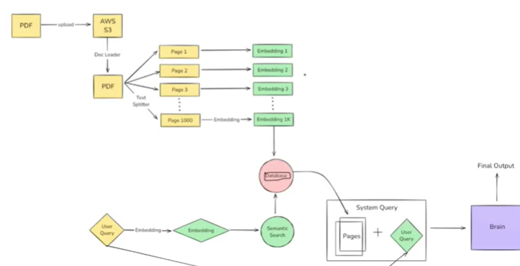

8. The “Brain” Problem and LLM Breakthrough
8.1 The Hardest Challenge
The most difficult part historically was building a system that:
- Understands user intent (NLU)
- Generates context-aware text
This problem was unsolved until Transformers.
8.2 Transformers → BERT → GPT → LLMs
The breakthrough came with:
- Transformer architecture
- Context-aware understanding
- Large-scale training
Today, LLMs solve both understanding and generation.

9. LLM APIs and Cost Problem
9.1 Hosting LLMs Yourself (Not Practical)
Challenges:
- Extremely high compute cost
- Infrastructure complexity
- Scaling issues
9.2 LLM APIs (Industry Solution)
Companies like:
- OpenAI
- Anthropic
- Google
These companies host these LLM’s on their own servers and they provide APIs to use these LLMs
Provide LLMs as APIs.
Benefits:
- No infrastructure management
- Pay-as-you-use
- Easy scaling
This makes GenAI commercially viable.
So, In the architecture instead of the Brain component – We use LLM API which solves the problem of text understanding and producing the results as user intent

10. The Real Challenge: Orchestration
Even with LLM APIs, the biggest challenge remains:
Managing multiple components and tasks together.
Problems include:
- Switching models
- Changing databases
- Modifying pipelines
- Handling dependencies
In the above pipeline, we can see that there are many interacting components such as the PDF uploader, document loader, text splitter, embedding model, and database storage.
Now, if we build this entire pipeline using OpenAI LLM APIs and design it specifically according to OpenAI’s supported interfaces, then later decide to switch to another provider like Gemini AI, we would need to modify multiple parts of the pipeline. This makes the process complex, time-consuming, and difficult to maintain.
This is where LangChain comes in. LangChain provides an abstraction layer that allows us to switch between different LLM providers (such as OpenAI, Gemini, etc.) with minimal changes to the pipeline, making the system more flexible and scalable.

11. Role of LangChain in the System
LangChain acts as the orchestration layer.
It:
- Connects all components
- Manages data flow
- Reduces boilerplate code
- Allows easy swapping of tools
Key idea:
You focus on business logic, LangChain handles plumbing.

12. Benefits of LangChain
12.1 Chains (Core Feature)
Chains allow:
- Sequential pipelines
- Parallel execution
- Conditional logic
Output of one step automatically becomes input of the next.
This is critical for complex GenAI workflows.

12.2 Model-Agnostic Development
You can:
- Switch from OpenAI → Google → Open-source
- Change embedding models
- Replace vector databases
Without rewriting core logic.
Whatever component it may be all it types are available in langchain

12.3 Complete Ecosystem
LangChain provides:
- Document loaders
- Text splitters
- Embedding integrations
- Vector DB integrations
- Memory handling
This makes it industry-friendly.

12.4 Memory and State Management
LangChain supports conversation memory.
Example:
- User: “What are aspects of linear regression?”
- User: “Give me interview questions on this”
The system remembers context, without repeating.

13. What Can You Build with LangChain?
13.1 Conversational Chatbots (Industry Use)
Used by:
- E-commerce companies
- FinTech apps
- SaaS platforms
Purpose:
- Handle customer queries
- Reduce call center load
- Improve scalability

13.2 AI Knowledge Assistants
Chatbots trained on company-specific data.
Used in:
- EdTech platforms
- Internal company tools
- Documentation assistants

13.3 AI Agents (Next Big Thing)
AI agents:
- Talk like humans
- Perform actions using tools
- Execute workflows
Example:
- Booking tickets
- Scheduling meetings
- Executing tasks autonomously

13.4 Research & Summarization Tools
Used to:
- Analyze large documents
- Summarize research papers
- Work with private company data

14. Alternatives to LangChain
LangChain is not the only framework.
Popular alternatives:
- LlamaIndex – strong for document indexing
- Haystack – enterprise-grade pipelines
Choice depends on:
- Use case
- Pricing
- Ecosystem fit

15. Industry Perspective (Where It’s Actually Used)
LangChain is widely used in:
- Startups building GenAI products
- Internal enterprise AI tools
- Customer support automation
- Knowledge management systems
It is not optional knowledge for GenAI engineers.

16. Project Ideas (Only Where Relevant)
Beginner
- PDF Question Answering System
- Course Material Chatbot
Intermediate
- Company Knowledge Assistant
- Resume Analyzer using embeddings
Advanced
- AI Agent for task automation
- Internal document search engine
These projects are resume-worthy and industry-aligned.

17. Key Takeaways (Exam + Interview Ready)
- LangChain is an orchestration framework, not an LLM
- Real GenAI apps require multiple components
- Semantic search + embeddings are foundational
- LLM APIs solved computation challenges
- LangChain solves orchestration complexity

